Photosynthesis:
Plants are able to produce Glucose from carbon dioxide and Water using a process called photosynthesis. The plant can use the glucose as fuel or to make whatever it might want such as fats or proteins. Animals which produce complex substances (glucose) using simple substances (CO2 and H2O) readily available from the environment are Called Autotrophic.
Chlorophyll is a green pigment which the plant uses to harness the energy of sunlight to drive the Photosynthesis reaction. It contains both Nitrogen and Magnesium.
The consumers which feed only on complex substances made by plants and animals are called Hetero trophs, hetero meaning different.

The following reactions summarize Photosynthesis:
Sunlight
Carbon Dioxide + Water Glucose + oxygen
Chlorophyll

Sunlight
6CO2 + 6 H2O C6H12O6 + 6 O2
Chlorophyll
C= Carbon O=Oxygen H= Hydrogen
Structure of the leaf:
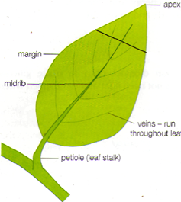
External structure of the leaf:
Apex- tip of the leaf.
Margin- edge of the leaf.
Midrib- largest vein running at the center of the leaf, also called the main vein.
Veins- carry water and other substances to the leaf and transport nutrients and waste products away.
Petiole- attaches the leaf to the branch also called the leaf stalk.

- Name the Products of photosynthesis?
- Which 2 substances are part of the plant to make chlorophyll?
- Write the chemical equation representing Photosynthesis.
- Identify 3 factors which are important to the process of photosynthesis.
- Define autotrophic nutrition.
- Define Heterotrophic nutrition.
- Find a leaf specimen which is at least 3 inches long. Make a detailed diagram of this leaf, labelling the 5 parts of the leaf and also attach the original specimen to your notebook. Please give title, magnification, border and other features of a diagram.

Structure of the layers of the leaf:
The leaf consists of 4 main layers from top to bottom these are:
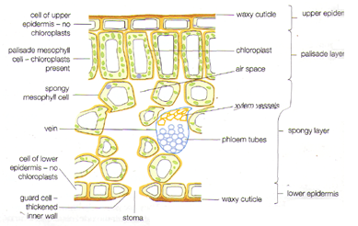
1. The upper epidermis: the top layer consisting of square regularly arranged cells, it contains few or no chloroplasts and is colorless to allow light to penetrate to lower layers. It also secretes waxes onto the surface of the leaf forming a waxy cuticle to prevent water loss from the leaf.
2. Palisade Mesophyll: “Meso” meaning middle, this layer consists of columnar shaped or vertically elongated cells. These cells contain the highest levels of chloroplasts anywhere of the leaf. The chloroplasts are positioned and circulate around the periphery of the cell to maximize their exposure to sunlight.
3. Spongy Mesophyll: this layer consists of loose fitting rounded cells, with large gaps between which allows gases to circulate. Also present here are specialized transport systems or vascular bundles containing; Xylem vessels which transport water and Phloem vessels which transport food substances to and from the leaf.
4. Lower epidermis: Composed of square regularly arranged cells like the Upper epidermis. Present on the surface of this layer are Stomata, which are holes or pores responsible over allowing gases to enter the leaf and also regulate the amount of water lost by the leaf. The size of the pore is controlled by specialized guard cells which swell or become turgid to close the hole or shrink becoming limp closing together.

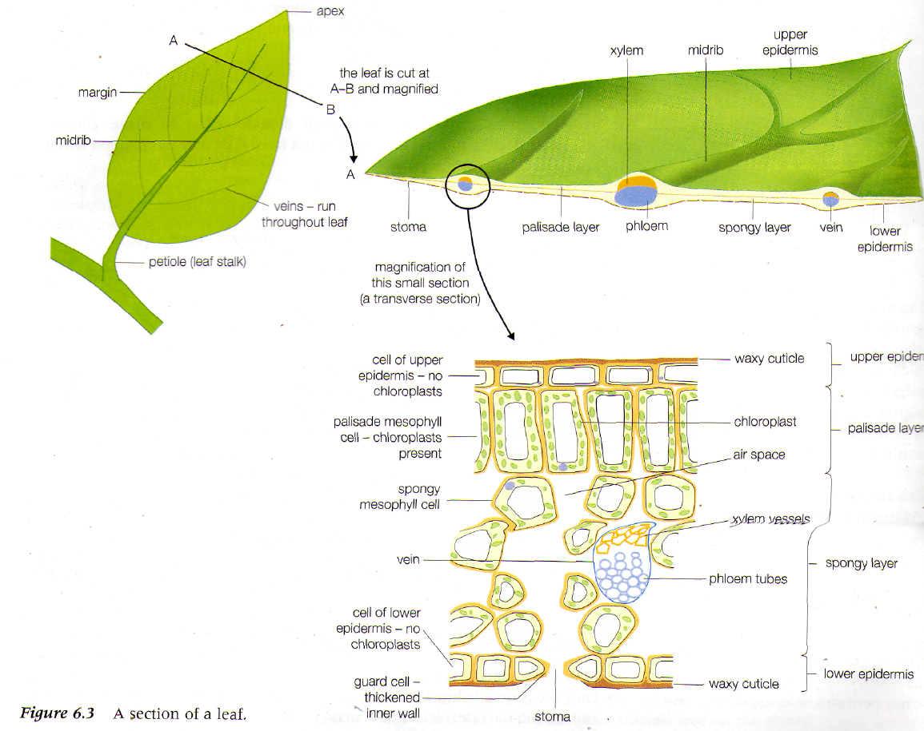

Adaptations of the leaf:
1. They lie at 90° to the sunlight and are spaced around the stem to catch as mi
light as possible.
2. The leaves are thin to allow light and carbon dioxide to reach all cells rapidly
3. Stomata (small holes) are present in the lower epidermis to allow gases to get to the cells of the leaf
and out easily.
4. Air spaces around the cells in the lower half of the leaf allow Carbon dioxide to get
to the chloroplasts as quickly as possible.
5. Chloroplasts are most numerous in cells in the palisade layer which is in the t
part of the leaf, closest to the sunlight.
6. Xylem vessels transport water to the leaf cells.
7. Phloem sieve tubes carry away the food made to the rest of the plant.
8. A waxy cuticle prevents water loss from the top of the leaf, and is transparent
to let light through.
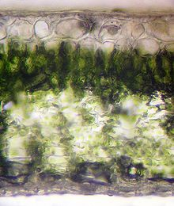
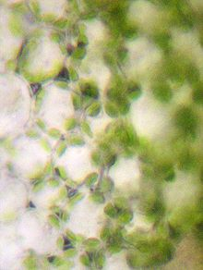

Cells of the palisade mesophyll (note the arrangement of chloroplasts around the boundary of the cell)
Cross section of the leaf (note the 4 layers of the leaf)

